Part 1

1.Is there relationship between points of players and the rebound of players ?

2.How the points effect to rebounds?

3.Is it all the time true that points increase means rebounds increase?

Part 2

I select two colums which are point are points and rebounds.

for showing my colums. I wrote simple code script which I learnt in course, and I got that result.

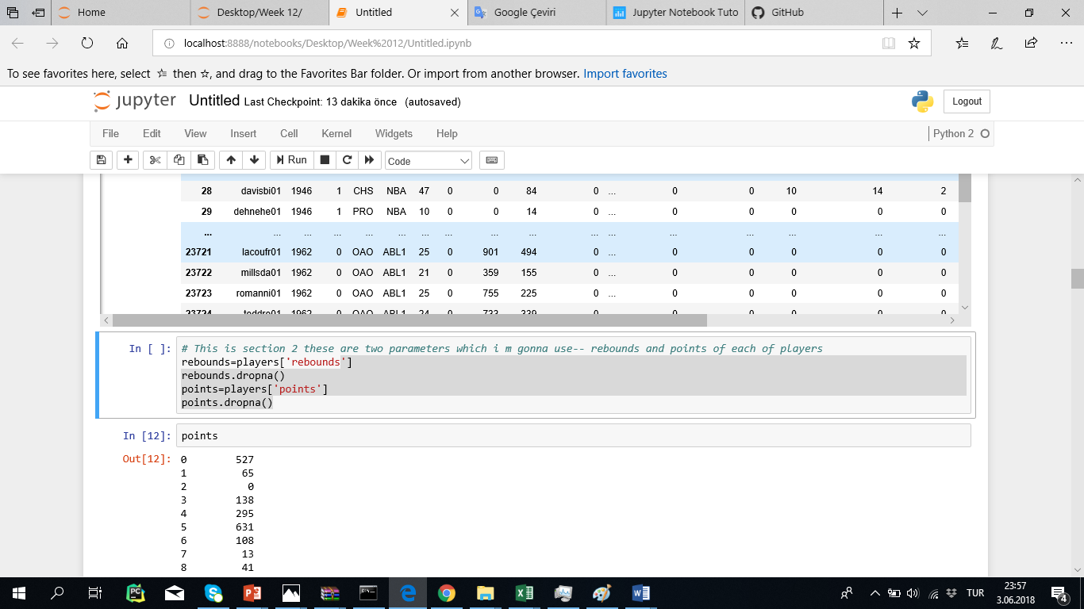

Part 3

5 descriptive values of points and rebounds

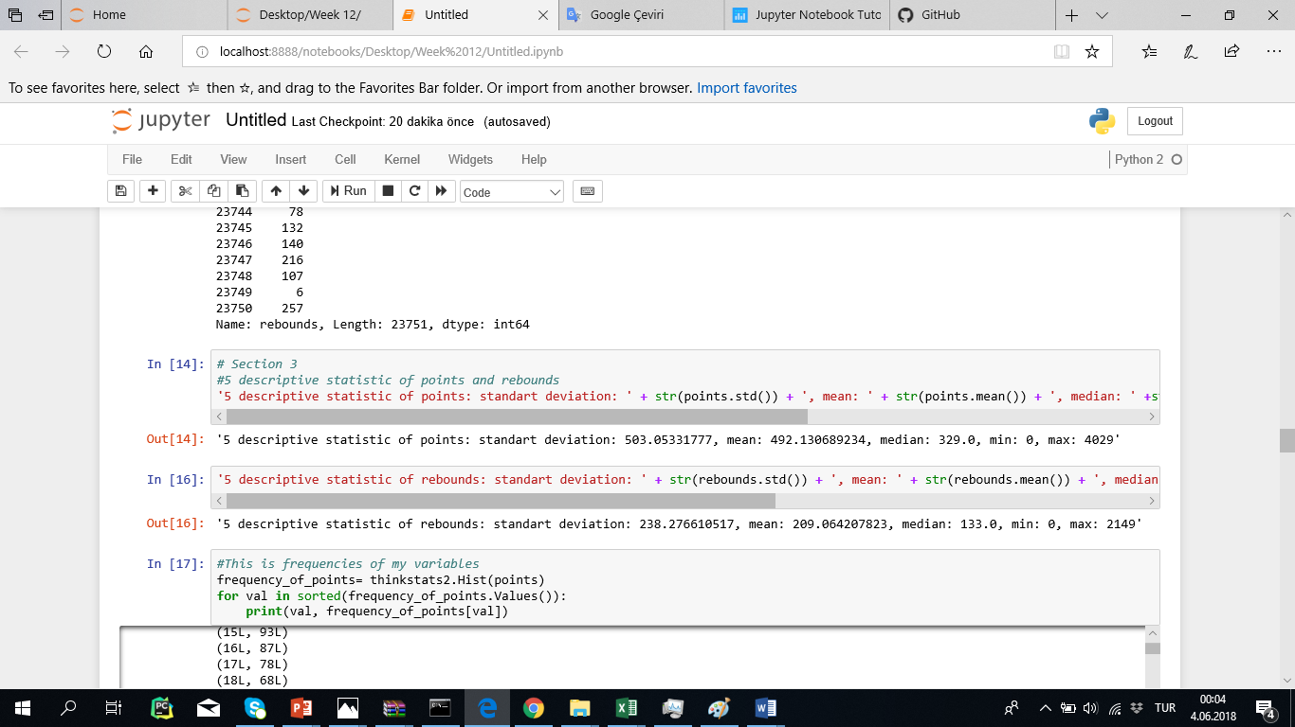

Part 4

This is the showing pmf cdf and histogram of my values as can see from down.

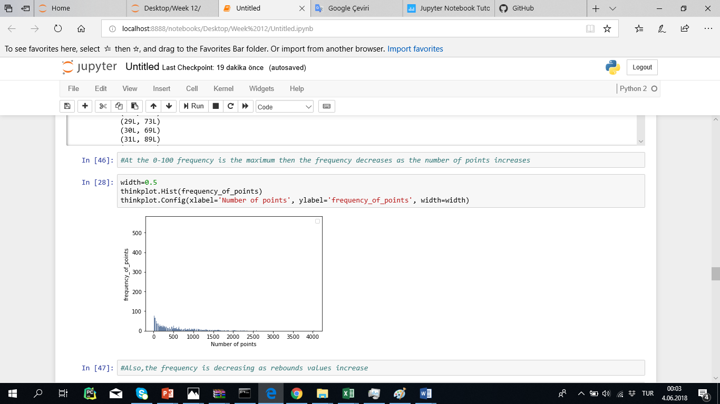 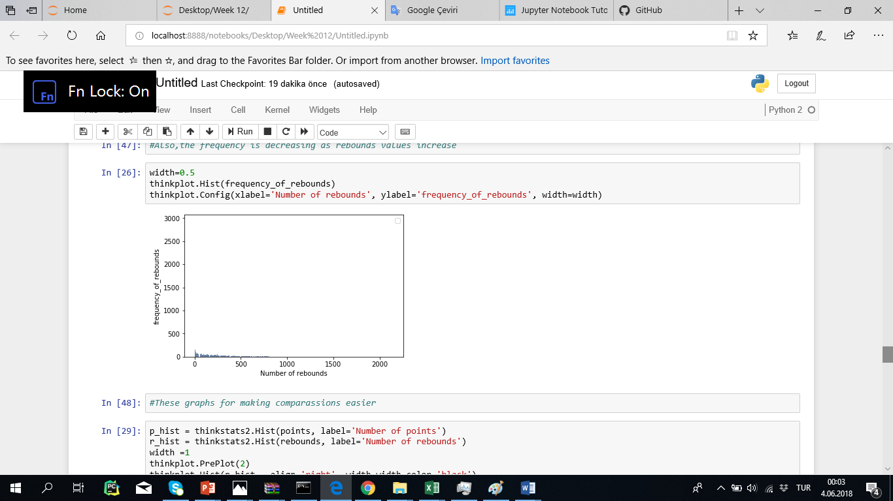

İ can realize from above it is not mean that the points is high and the rebounds is high.

Part 5

İ test my hypotes which is the first question there is relation between points and the rebound but it is not true all the time rebounds can be 0 and the points can very high.

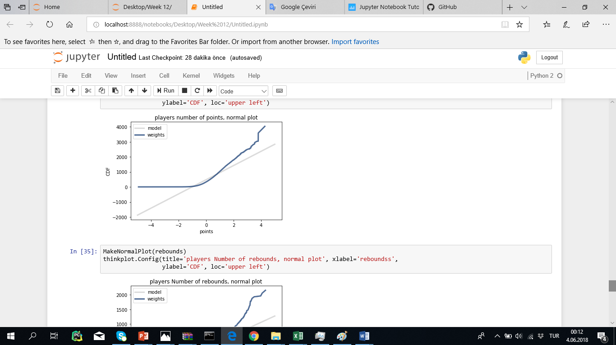

Part 6 and 7 answred in jupyter notebooks.